

WEEK 3, T4 - 2015
Score ( x / 23 ) | %

LAKELAND SHS MATHEMATICS

MATHEMATICS METHODS UNIT 2
test 3 – Part a

NAME: ______________________________ Time allowed: 25 min

CALCULATOR FREE AND NOTE FREE SECTION

- Differentiate 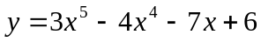 with respect to . [1 mark]

2. [2 marks]
If y = x³ + 2x + 4 when x = –3, find the instantaneous rate of change of y with respect to x
when x = –3.

3. [3 marks]

Gas is being forced into a gas tank. The amount of gas G L in the tank after t seconds is given by the formula G(t) = t² + 3t + 4. What is the average rate of change from t = 4 to t = 7?

4. [3 marks]

The position of a particle at time t seconds is given by x = 2t³ – 18t² + 48t + 18. Find any times the particle is at rest.

5. [1 mark]

The position in metres of a particle at time t seconds is given by x = 2t³ – 15t² + 36t + 12. What is the initial position of the particle?

6. [5 marks]

Find the point(s) on the graph of y = –x² + 2x – 2 where the slope of the curve is 8.

7. [5 marks]
Given that 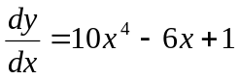, and that when 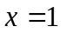, 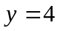 , find the value of when 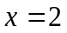.

8. [3 marks]
The position x m of a falling object at any time t seconds is given by
x = –5t² + 8t + 117.

Find its acceleration after 5 seconds. Take upwards to be the positive direction.

WEEK 3, T4 - 2015
Score ( x / 31) | %

LAKELAND SHS MATHEMATICS

MATHEMATICS METHODS UNIT 2
test 3 – Part B

NAME: ______________________________ Time allowed: 35 min

CALCULATOR AND NOTES ASSUMED

9. Find the equation of the tangent for the following curve at the indicated point. [6 marks]

y = 2x - 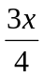 + 5 at the point (1, 6.25)

10. Find and identify any stationary points of f(x) = 3x³ + 9x² + 9x – 7. [9 marks]

11. [4 marks]

The height h m of a projectile at any time t seconds is given by h = –5t² + 22t + 22. What will be its maximum height?

12. [10 marks]
A box is made by cutting square corners out of a rectangular piece of tin and folding the sides up.

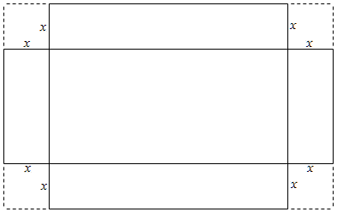

If the original piece of tin measures 63 cm by 15 cm, and the squares have side length x cm, find the maximum possible volume of the box formed.

You may wish to use CAS for parts of this question.

13. [2 marks]

Which of the following could be the graph of the gradient function of the graph below?

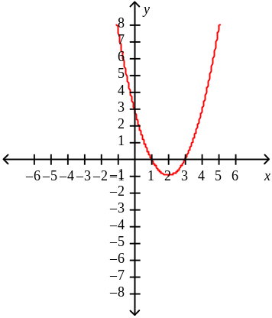

A | 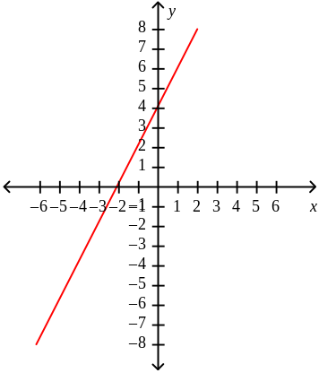 | D | 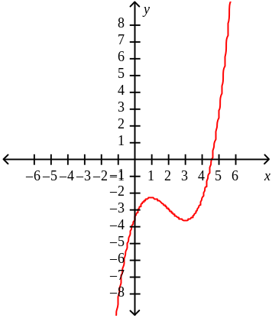
B | 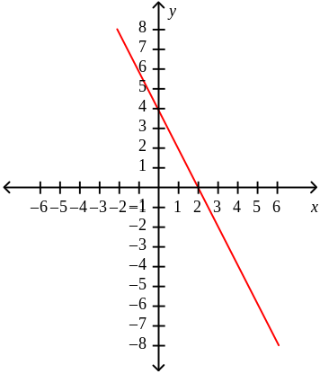 | E
C | 